Freelancer Marketplace Database System
Submitted in partial fulfillment of the requirements.
of the degree of
Bachelor of Technology
in
Artificial Intelligence & Machine Learning
by
Abhishek raja-125A9028
Aravind Nadar-125A9029
Manish Nadar-125A9031
Murlidharan Naidu-125A9033
Under the Guidance of
Prof. Sumedha Maindalkar

Department of Artificial Intelligence & Machine Learning
SIES GRADUATE SCHOOL OF TECHNOLOGY
Nerul, Navi Mumbai 400706
University of Mumbai
2025-2026

CERTIFICATE
This is to certify that the project entitled “Freelancer Marketplace Database System” is a bonafide work of the following students, submitted to the University of Mumbai in partial fulfillment of the requirement for the award of the degree of Bachelor of Technology in Artificial Intelligence & Machine Learning.
Abhishek raja-125A9028
Aravind Nadar-125A9029
Manish Nadar-125A9031
Murlidharan Naidu-125A9033

Prof. Sumedha Maindalkar | Dr. Kalyani N. Pampattiwar | Dr. K. Lakshmi Sudha
Internal Guide | Head of Department | Principal

DECLARATION
I declare that this written submission represents our ideas in our own words and where others’ ideas or words have been included, we have adequately cited and referenced the original sources. We also declare that we have adhered to all principles of academic honesty and integrity and have not misrepresented or fabricated or falsified any idea, data, fact or source in our submission. We understand that any violation of the above will cause for disciplinary action by the Institute and can also evoke penal action from the sources which have thus not been properly cited or from whom proper permission has not been taken when needed.

Abhishek raja-125A9028 | Signature
Aravind Nadar-125A9029 | Signature
Manish Nadar-125A9031 | Signature
Murlidharan Naidu-125A9033 | Signature
Date:

ACKNOWLEDGEMENT
It gives us immense pleasure to thank our principal for extending support in carrying out this project. We also thank our Head of Department for support in completing the project. We wish to express our deep sense of gratitude and thanks to our Internal Guide for guidance, help and useful suggestions, which helped in completing our project work in time.
Also, we would like to thank the entire faculty of the Artificial Intelligence and Machine Learning department for their valuable ideas and timely assistance in this project. Last but not least, we would like to thank our teaching and non-teaching staff members of our college for their support in facilitating timely completion of this project.

Project Team
Abhishek raja
Aravind Nadar
Manish Nadar
Murlidharan Naidu

ABSTRACT
This report presents the design and implementation of a relational database for a Freelancer Marketplace, an online platform on which clients post projects, freelancers submit bids, and an accepted bid is formalised as a contract that is followed by payments and reviews. The work is carried out in three stages: conceptual design using an Entity-Relationship (ER) model, extension of that design using an Enhanced Entity-Relationship (EER) model, and physical implementation using SQL Data Definition Language (DDL) in PostgreSQL.
The ER model identifies eight entities (Client, Project, Bid, Freelancer, Contract, Payment, Review and Skill) together with their primary keys and their simple, derived and multivalued attributes, and defines seven relationships with their mapping cardinalities (one-to-one, one-to-many and many-to-many). The EER model refines the design by introducing generalization/specialization (ISA), in which the Freelancer supertype is specialised into Individual Freelancer and Company Freelancer subtypes.
The design was then implemented in a database named freelancer_marketplace using PostgreSQL and pgAdmin 4. DDL commands (CREATE TABLE, ALTER TABLE, RENAME, ADD COLUMN and DROP COLUMN) were used to build and modify nine tables, while integrity constraints (PRIMARY KEY, FOREIGN KEY, NOT NULL, UNIQUE, CHECK and DEFAULT) were applied to keep the stored data accurate, valid and consistent. A junction table was used to resolve the many-to-many relationship between freelancers and skills, and the final list of tables was verified through the information_schema catalogue. The project demonstrates the complete path from requirements to a working relational schema.

Contents
SR. NO. | CHAPTER | PAGE NO.
1 | INTRODUCTION | 4
2 | SYSTEM REQUIREMENTS: S/W used | 6
3 | SYSTEM DESIGN: ER-DIAGRAM | 8
4 | IMPLEMENTATION | 12
5 | CODE SNIPPETS (SQL DDL) | 18
6 | RESULT | 21
7 | CONCLUSION | 25

Chapter 1: Introduction
1.1 Introduction and need of the project
The digital economy has made online freelancing one of the most common ways in which individuals and organisations obtain specialised services. Web developers, designers, writers, data analysts and many other professionals now offer their skills to clients located anywhere, and clients in turn expect to be able to find, compare and hire suitable professionals quickly. As the number of clients, freelancers and projects grows, so does the amount of information that must be recorded and related: who posted which project, which freelancers bid for it, which bid was accepted, what was agreed, what was paid, and how the work was rated afterwards. This project addresses the need to store and manage all of this information in a structured database by designing and implementing the database for a Freelancer Marketplace.
The primary need for the project comes from the way freelance work is still managed in many places. Hiring freelancers and tracking freelance projects through e-mails, social media or messaging applications is unorganised and time-consuming. Clients find it difficult to identify suitable freelancers, while freelancers struggle to discover genuine projects that match their skills. When project details, bids, contracts, payments and reviews are tracked manually, the result is confusion, delays and poor record management. A centralised platform backed by a well-designed database removes these problems: every record has a single, well-defined place, related records are linked through keys, and the hiring process becomes transparent, organised, secure and efficient.
Beyond record keeping, the project addresses the discipline of database design itself. A good database is not created by writing tables directly; it begins with a conceptual model that captures the real-world entities, their attributes and the relationships between them. In this project the model is first drawn as an Entity-Relationship (ER) diagram, then extended into an Enhanced Entity-Relationship (EER) diagram that uses generalization and specialization to distinguish Individual Freelancers from Company Freelancers, and finally translated into a physical PostgreSQL database with Data Definition Language (DDL) commands and integrity constraints. Following this sequence keeps the design consistent from the requirements down to the tables, reduces redundancy, and provides a reliable foundation on which a full Freelancer Marketplace application could later be built.
In conclusion, the Freelancer Marketplace Database System replaces scattered, manual handling of freelance data with an organised and consistent structure. It shows how ER/EER modelling and SQL DDL work together to turn a plain-language problem statement into a set of related tables in which primary keys, foreign keys and other constraints enforce the rules of the business automatically.
1.2 Problem statement in broad sense
The rapid growth of the digital economy has increased the demand for online freelancing platforms that connect clients with skilled professionals. However, managing freelancers, projects, bids, contracts, payments and reviews manually or across multiple communication platforms leads to inefficiency, poor organisation and difficulty in maintaining accurate records. Clients often struggle to find suitable freelancers, while freelancers face challenges in discovering projects that match their expertise.
The Freelancer Marketplace is therefore designed as a centralised database system in which clients can post projects, freelancers can submit bids, and a contract is created once a bid is accepted. The system also maintains payment records, freelancer skills and customer reviews so that the entire project life cycle is transparent and easy to manage. The main objective is to maintain all marketplace information in a structured database that makes the hiring process transparent, organised, secure and efficient.
1.3 Objectives
The objectives of the project are:
• To maintain records of clients and freelancers.
• To classify freelancers into Individual Freelancers and Company Freelancers using the ISA (specialization) concept.
• To allow clients to post projects and freelancers to submit bids for available projects.
• To generate contracts after a bid is accepted.
• To record payment details for completed work and manage them securely.
• To maintain freelancer skills and expertise.
• To collect ratings and reviews after project completion.
• To design the ER and EER diagrams showing entities, attributes, relationships and mapping cardinalities.
• To implement the database in PostgreSQL using DDL commands and to apply integrity constraints (primary key, foreign key, not null, unique, check and default).
• To organise all marketplace information in a structured and efficient database.
1.4 Scope
The project covers the complete design and creation of the database structure for the Freelancer Marketplace. On the design side, the scope includes the ER model (Experiment 1) and the EER model with ISA specialization (Experiment 2), with all entities, attributes (simple, derived and multivalued), primary keys, relationships and mapping cardinalities documented and drawn as diagrams.
On the implementation side, the scope includes creating a PostgreSQL database named freelancer_marketplace using pgAdmin 4 (Experiment 3), creating the entity and relationship tables with DDL commands, modifying table structure with ALTER TABLE operations (rename, add column, drop column), applying integrity constraints, and displaying the final list of tables to verify the result. The project concentrates on the structure (schema) of the database. Data manipulation, complex querying, and a user-facing application are outside its scope, but the schema is designed so that they can be added later.
1.5 Organization of the report
This report is organised into seven chapters followed by a list of references, documenting the design and implementation of the Freelancer Marketplace Database System.

Chapter 2: System Requirements (software used)
2.1 Microsoft Windows Operating System
The database was created and tested on a Windows-based computer. PostgreSQL and pgAdmin 4 are both available for Windows, and the pgAdmin 4 graphical interface was used for all the work described in this report, including running SQL statements and browsing the resulting database objects.
2.2 PostgreSQL
PostgreSQL is a free, open-source object-relational database management system that supports standard SQL. The experiments were run on a PostgreSQL server. A server connection named demo was registered in pgAdmin 4, and on this server the database freelancer_marketplace was created alongside the default postgres database. PostgreSQL was chosen because it provides full support for the constraints required in this project, including primary and foreign keys, UNIQUE, NOT NULL, CHECK and DEFAULT, and it offers the SERIAL data type for automatically generated identifiers.
2.3 pgAdmin 4
pgAdmin 4 is a widely used open-source graphical administration and development tool for PostgreSQL. The following parts of its interface were used in this project:
• Object Explorer: a tree view of servers, databases, schemas and tables, used to confirm that each table was created, renamed or altered.
• Query Tool: the SQL editor in which the DDL commands were typed and executed.
• Messages and Data Output tabs: the Messages tab reports the outcome of each command (for example CREATE TABLE or ALTER TABLE and the execution time), and the Data Output tab displays the rows returned by a query.
2.4 SQL DDL and integrity-constraint features used
Data Definition Language (DDL) is the set of SQL commands used to define and modify the structure or schema of database objects such as databases and tables. Unlike Data Manipulation Language (DML), which works with the data stored inside the tables, DDL deals with the structure itself. The DDL operations used in this project are listed in Table 2.1.
Table 2.1: DDL commands used
SR. NO. | CHAPTER | PAGE NO.
1 | INTRODUCTION | 7
2 | SYSTEM REQUIREMENTS: S/W used | 10
3 | SYSTEM DESIGN: ER-DIAGRAM | 12
4 | IMPLEMENTATION | 16
5 | CODE SNIPPETS (SQL DDL) | 22
6 | RESULT | 25
7 | CONCLUSION | 27

Integrity constraints are rules applied to tables so that the stored data remains accurate, valid and consistent. The constraints applied in this project are listed in Table 2.2.
Table 2.2: Integrity constraints used
Command | Purpose
CREATE | Creates a new database or table with specified columns, data types and constraints.
ALTER TABLE | Modifies the structure of an existing table by adding, removing or changing columns and constraints.
RENAME TO | Changes the name of an existing table without deleting its data.
ADD COLUMN | Adds a new column to an existing table.
DROP COLUMN | Removes an existing column from a table.

2.5 Prerequisites
Basic knowledge of database management systems, SQL DDL commands and integrity constraints is required to follow the implementation described in this report.

Chapter 3: System Design: ER Diagram
3.1 Design approach and notation
The conceptual design of the Freelancer Marketplace was carried out in two steps. Experiment 1 produced an Entity-Relationship (ER) model, and Experiment 2 extended it into an Enhanced Entity-Relationship (EER) model by adding an ISA (generalization/specialization) hierarchy. Both diagrams use the same notation: entities are drawn as rectangles and relationships as diamonds; simple attributes are drawn as single ovals, the primary key is underlined, derived attributes (calculated from other data) are drawn as dashed ovals, and multivalued attributes (which can hold more than one value) are drawn as double ovals. The mapping cardinality is written beside each relationship as 1 or M (or N).
3.2 Entity-Relationship model (Experiment 1)
The ER model identifies eight entities. Their keys and attributes are summarised in Table 3.1, and the complete diagram is shown in Figure 3.1.
Table 3.1: Entities and attributes of the ER model
Constraint | Purpose
PRIMARY KEY | Uniquely identifies each record in a table.
FOREIGN KEY | Establishes a relationship between two tables and maintains referential integrity.
NOT NULL | Ensures that a column cannot contain a null value.
UNIQUE | Prevents duplicate values in a column.
CHECK | Ensures that values satisfy a specified condition.
DEFAULT | Automatically assigns a predefined value when no value is provided.

The CLIENT entity represents a person or organisation that posts projects and hires freelancers. The PROJECT entity stores the details of the projects posted by clients, including budget, deadline and status (Open, Ongoing, Completed and so on), and its derived attribute days_remaining is calculated from the current date and the deadline. The BID entity represents a proposal submitted by a freelancer for a project; a bid can carry several attachments (a multivalued attribute) and its is_accepted attribute is derived from the bid status. The FREELANCER entity represents the professionals who offer services by bidding on projects, with total_experience_years derived from work experience. The CONTRACT entity represents the agreement created after a bid is accepted, with duration_days derived from the start and end dates. The PAYMENT entity stores the payment made for completed work; one payment can have several invoice numbers, and tax_amount and net_amount are derived from the payment amount. The REVIEW entity stores the rating and feedback given after project completion, with rating_stars derived from the numerical rating. The SKILL entity stores the skills available on the marketplace (for example Java, Python and UI/UX Design) together with alternative names (aliases).
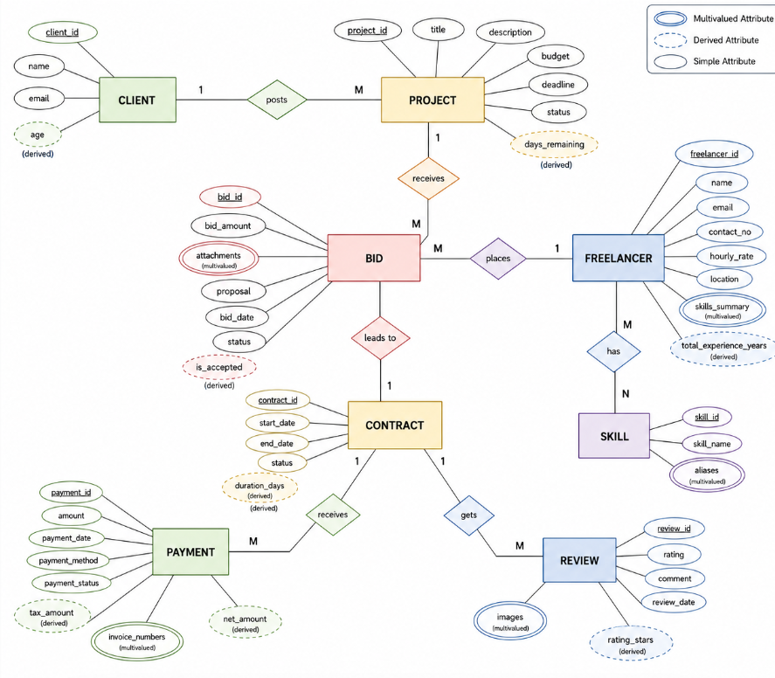
Figure 3.1: ER diagram of the Freelancer Marketplace
The seven relationships of the ER model and their mapping cardinalities are given in Table 3.2.
Table 3.2: Relationships and mapping cardinality (ER model)
Entity | Primary key | Simple attributes | Derived attribute(s) | Multivalued attribute(s)
CLIENT | client_id | name, email | age (from date of birth) | —
PROJECT | project_id | title, description, budget, deadline, status | days_remaining | —
BID | bid_id | bid_amount, proposal, bid_date, status | is_accepted | attachments
FREELANCER | freelancer_id | name, email, contact_no, hourly_rate, location | total_experience_years | skills_summary
CONTRACT | contract_id | start_date, end_date, status | duration_days | —
PAYMENT | payment_id | amount, payment_date, payment_method, payment_status | tax_amount, net_amount | invoice_numbers
REVIEW | review_id | rating, comment, review_date | rating_stars | images
SKILL | skill_id | skill_name | — | aliases

3.3 Enhanced Entity-Relationship model (Experiment 2)
The EER model keeps every entity and relationship of the ER model and extends the design in two ways. First, the CLIENT entity gains a contact_no attribute. Second, and more importantly, the FREELANCER entity becomes a supertype that is specialised into two subtypes through an ISA relationship, as shown in Figure 3.2. This reflects a real-world distinction: some freelancers work independently as individuals, while others provide services through a registered company.
Table 3.3: Supertype and subtypes in the ISA hierarchy
No. | Relationship | Entities | Cardinality | Explanation
1 | posts | Client — Project | 1 : M | A client can post many projects; each project is posted by only one client.
2 | receives | Project — Bid | 1 : M | A project can receive bids from several freelancers; each bid is for only one project.
3 | places | Freelancer — Bid | 1 : M | A freelancer can place many bids; each bid is placed by only one freelancer.
4 | leads to | Bid — Contract | 1 : 1 | An accepted bid results in one contract; each contract originates from one accepted bid.
5 | receives | Contract — Payment | 1 : M | A contract can receive one or more payments (for example in instalments); each payment belongs to one contract.
6 | gets | Contract — Review | 1 : M | A completed contract can receive reviews; each review belongs to one contract.
7 | has | Freelancer — Skill | M : N | A freelancer can have many skills and a skill can be possessed by many freelancers.

Every subtype inherits all the common attributes of the Freelancer entity and adds its own specific attributes. The ISA relationship is documented as a one-to-one specialization. Placing the attributes that apply to only one kind of freelancer in a subtype avoids filling the general Freelancer entity with attributes that are empty for most records, which reduces redundancy and makes the design more flexible. All the other relationships (posts, receives, places, leads to, receives, gets and has) and their cardinalities remain as in Table 3.2.
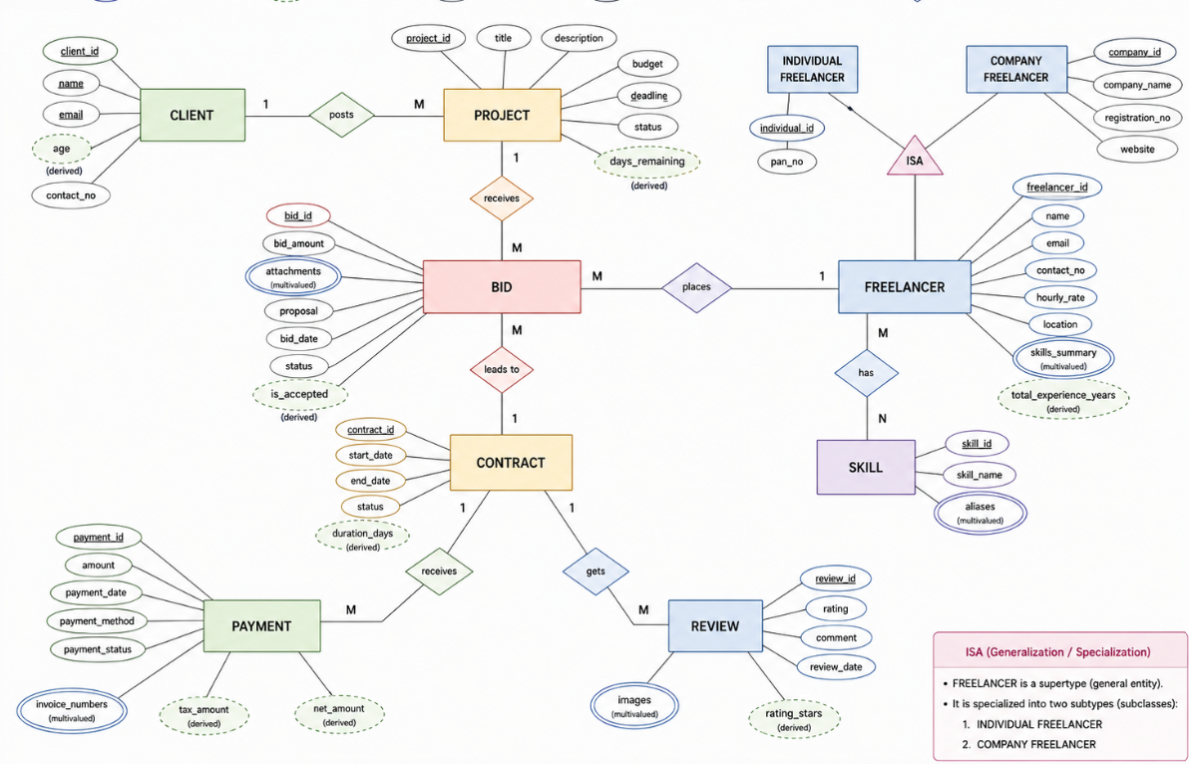
Figure 3.2: EER diagram of the Freelancer Marketplace with ISA specialization
3.4 From conceptual design to the relational implementation
In Experiment 3 the conceptual design was carried into PostgreSQL. The database freelancer_marketplace contains the tables users, clients, freelancers, skills, project, bids, payments and reviews, together with a relationship (junction) table freelancer_skills. The junction table resolves the many-to-many relationship “Freelancer has Skill” of the ER model: each row pairs one freelancer_id with one skill_id, and the pair is the primary key. The one-to-many relationships are represented by foreign keys; for example, a bid refers to the project it is for and to the freelancer who placed it. Chapters 4 and 5 describe this implementation in detail.

Chapter 4: Implementation
The implementation of the Freelancer Marketplace database was carried out in PostgreSQL using the Query Tool of pgAdmin 4. The database was created first, followed by the entity tables, then the DDL modification operations, and finally the relationship tables and foreign keys. Each step is described below together with the screenshot of its execution. The SQL statements themselves are listed and explained in Chapter 5.
4.1 Connecting to the server and creating the database
Step 1 was to open pgAdmin 4 and connect to the PostgreSQL server. Step 2 was to create a new database named freelancer_marketplace using the CREATE DATABASE command. Figure 4.1 shows the Query Tool connected to the freelancer_marketplace database on the server demo.
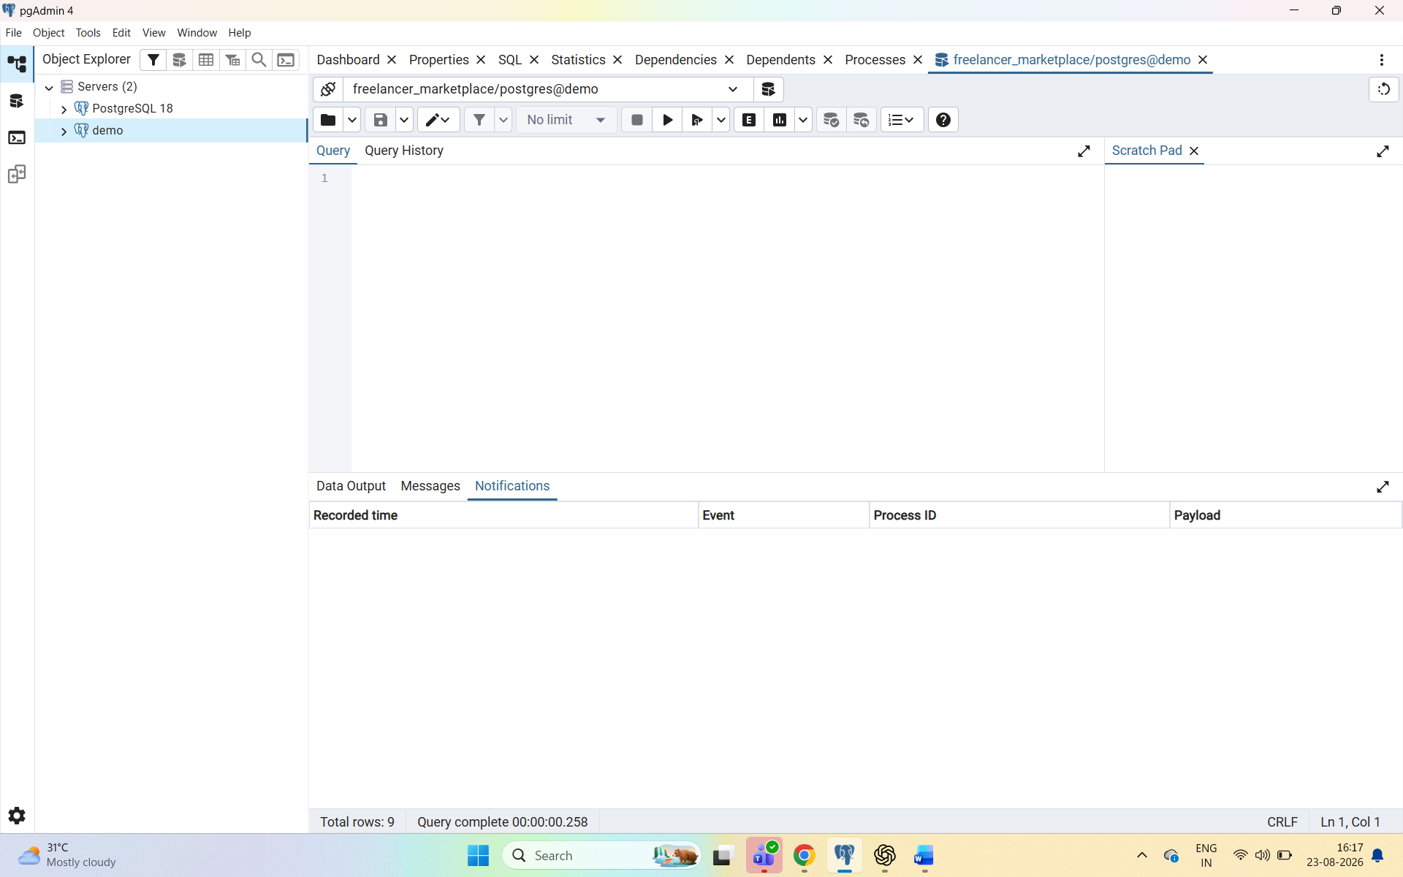
Figure 4.1: pgAdmin 4 Query Tool connected to the freelancer_marketplace database
Figure 4.2 shows the Object Explorer after the database was created: the server now lists two databases, freelancer_marketplace and postgres. The figure also records an error that occurred when the statement USE freelancer_marketplace; was run. Unlike some other database systems, PostgreSQL has no USE command, so the server reported a syntax error (SQLSTATE 42601). In PostgreSQL the working database is chosen by connecting to it, which pgAdmin 4 does through the connection shown in the Query Tool toolbar, and the statement is not needed.
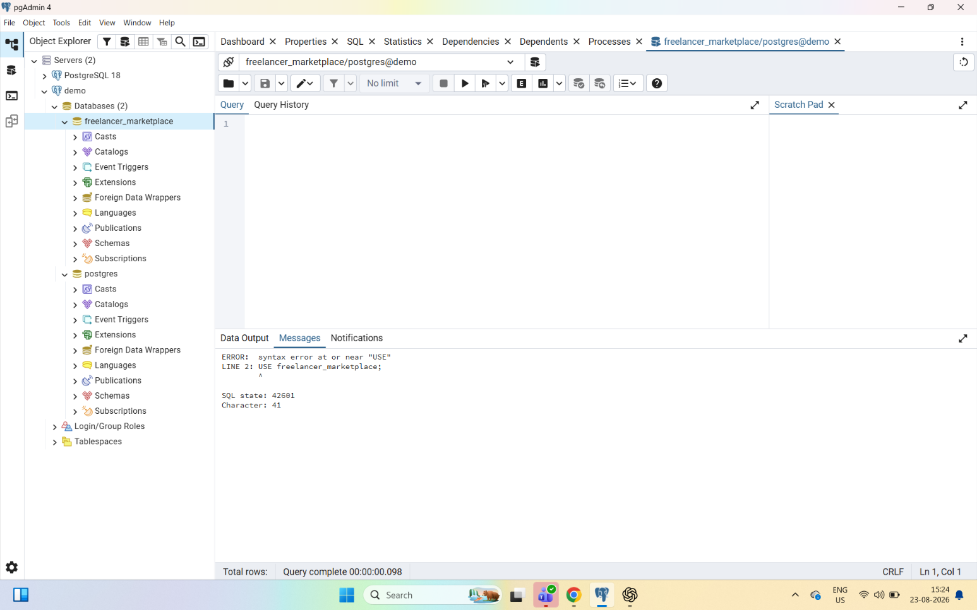
Figure 4.2: Object Explorer showing the new database, and the error raised by the USE statement
4.2 Creating the Users table
Step 3 was to create the users table with the CREATE TABLE command and apply integrity constraints. The table holds the common details of every person on the platform. Its primary key is an auto-generated user_id (SERIAL), name is mandatory, email is both mandatory and unique so that two accounts cannot share an e-mail address, and a CHECK constraint restricts user_type to the values Client and Freelancer. Figure 4.3 shows the successful execution.
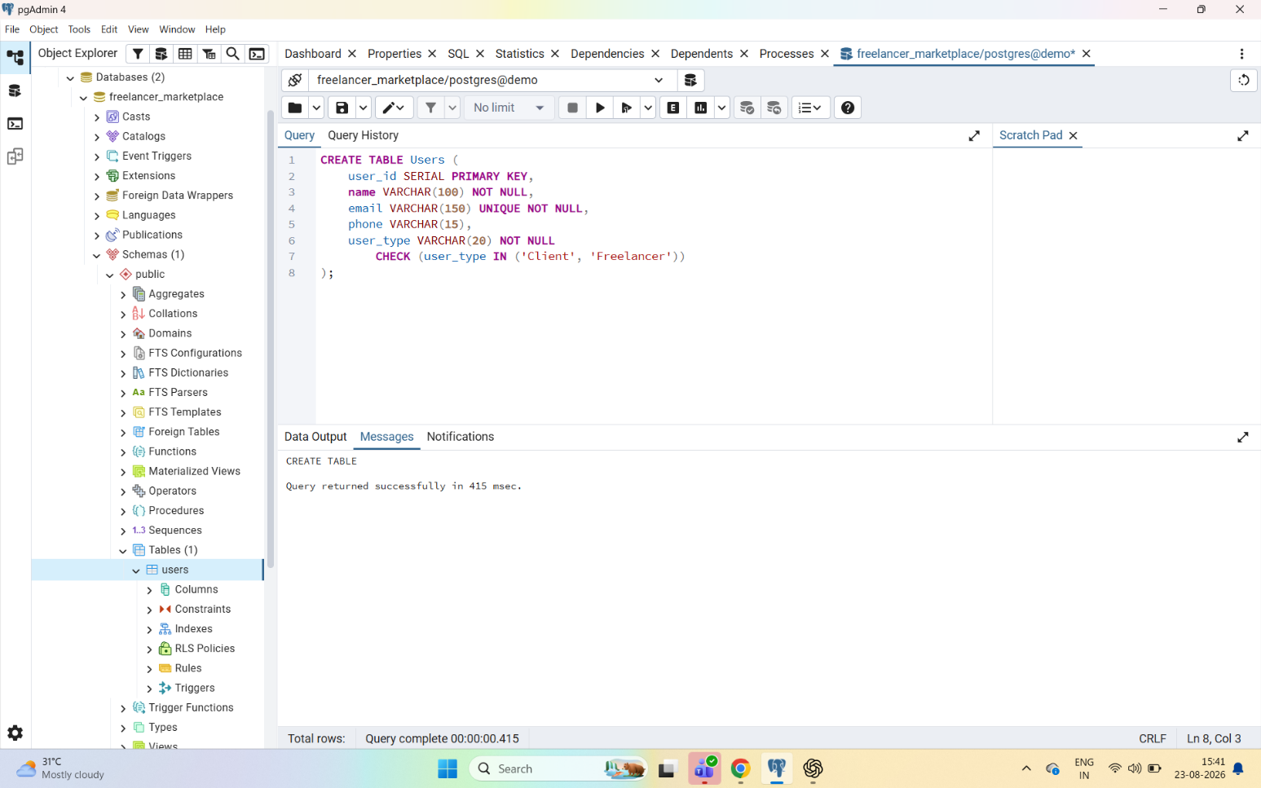
Figure 4.3: Creating the Users table with integrity constraints
4.3 Creating the remaining entity tables
Step 4 was to create the remaining entity tables. The projects table was created with a primary key, a mandatory title, a budget that must be greater than zero, a status that defaults to Open and is restricted to four permitted values, and start and deadline dates (Figure 4.4). The tables for skills, bids, payments, reviews, clients and freelancers were created in the same way, using CREATE TABLE with suitable data types and constraints, and each of them appears in the Object Explorer as it is created.
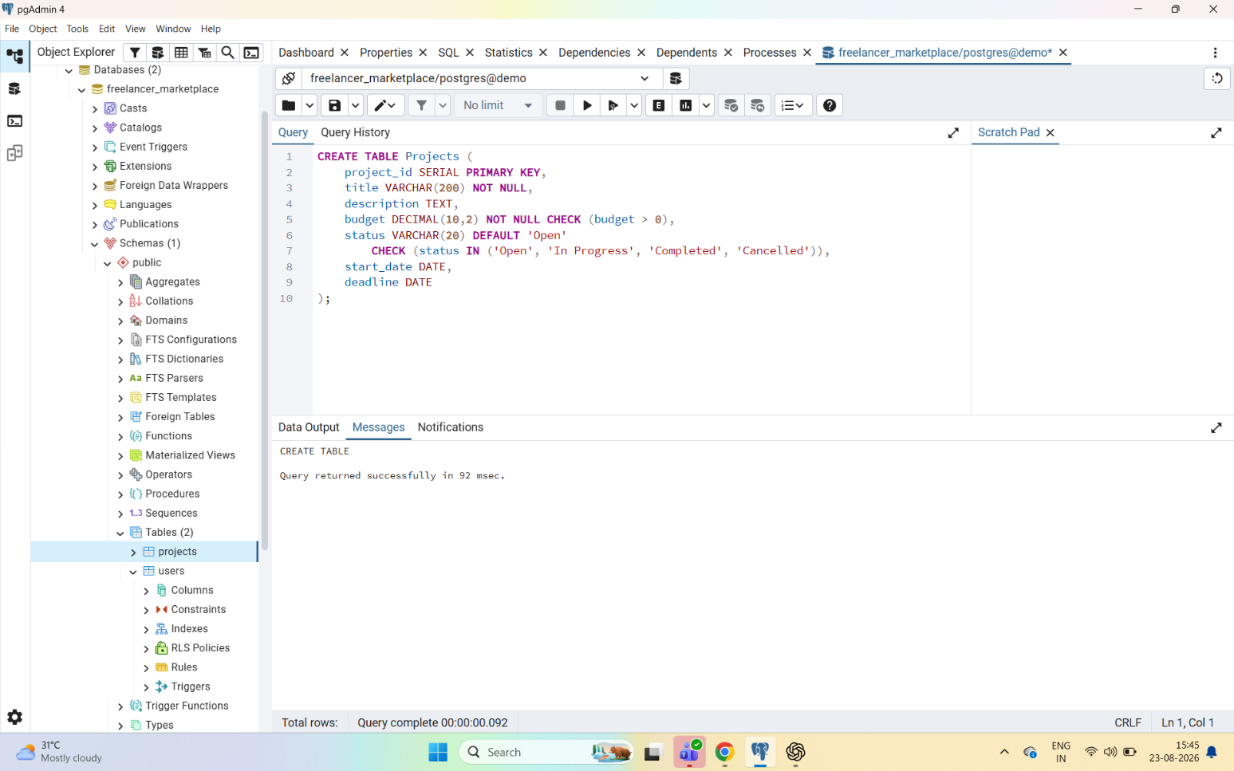
Figure 4.4: Creating the Projects table (CHECK and DEFAULT constraints)
4.4 Performing DDL operations
Step 5 was to demonstrate the ALTER TABLE operations on the project table. First the table projects was renamed to project (Figure 4.5). Then a new column, remarks, was added to the project table (Figure 4.6), and finally the same column was dropped again (Figure 4.7). In each case pgAdmin 4 reported ALTER TABLE and the Object Explorer continued to show the table, confirming that its data and structure were preserved apart from the requested change.
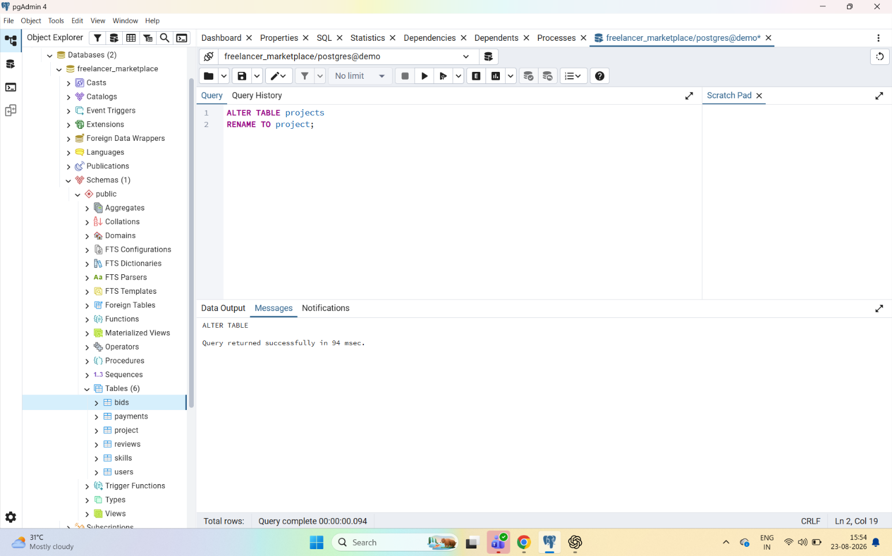
Figure 4.5: Renaming the projects table to project
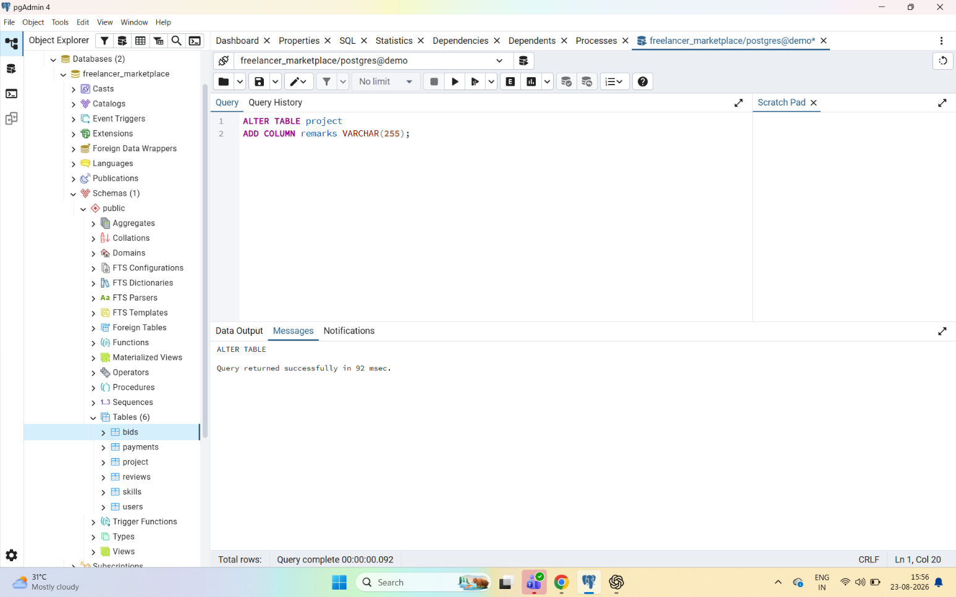
Figure 4.6: Adding the remarks column to the project table
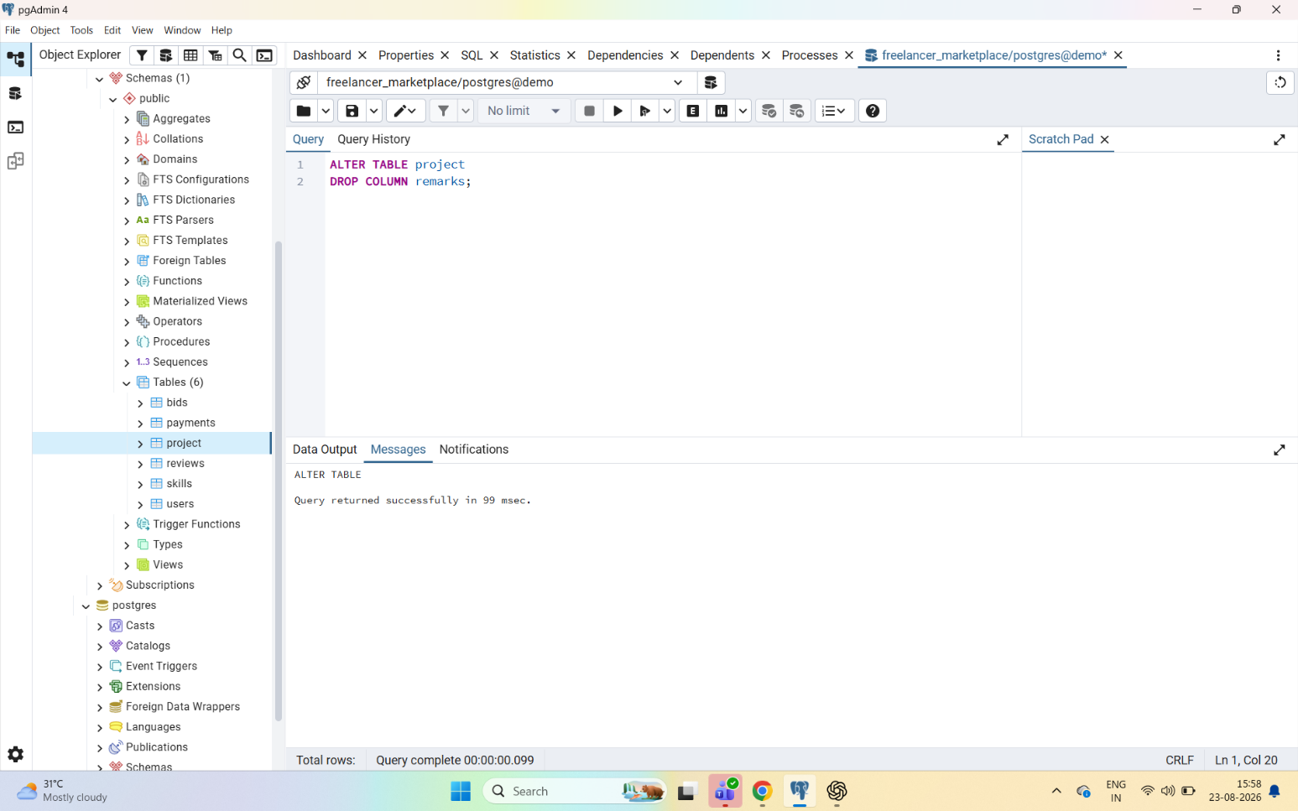
Figure 4.7: Dropping the remarks column from the project table
4.5 Creating the relationship tables and foreign keys
Step 6 was to create the relationship tables and link the tables with foreign keys. The many-to-many relationship between freelancers and skills was implemented with the junction table freelancer_skills, whose primary key is the combination of freelancer_id and skill_id and whose two columns are foreign keys referencing the freelancers and skills tables (Figure 4.8). The one-to-many relationships of a bid with its project and with its freelancer were implemented by adding project_id and freelancer_id columns to the bids table and then adding the foreign-key constraints fk_bid_project and fk_bid_freelancer (Figure 4.9).
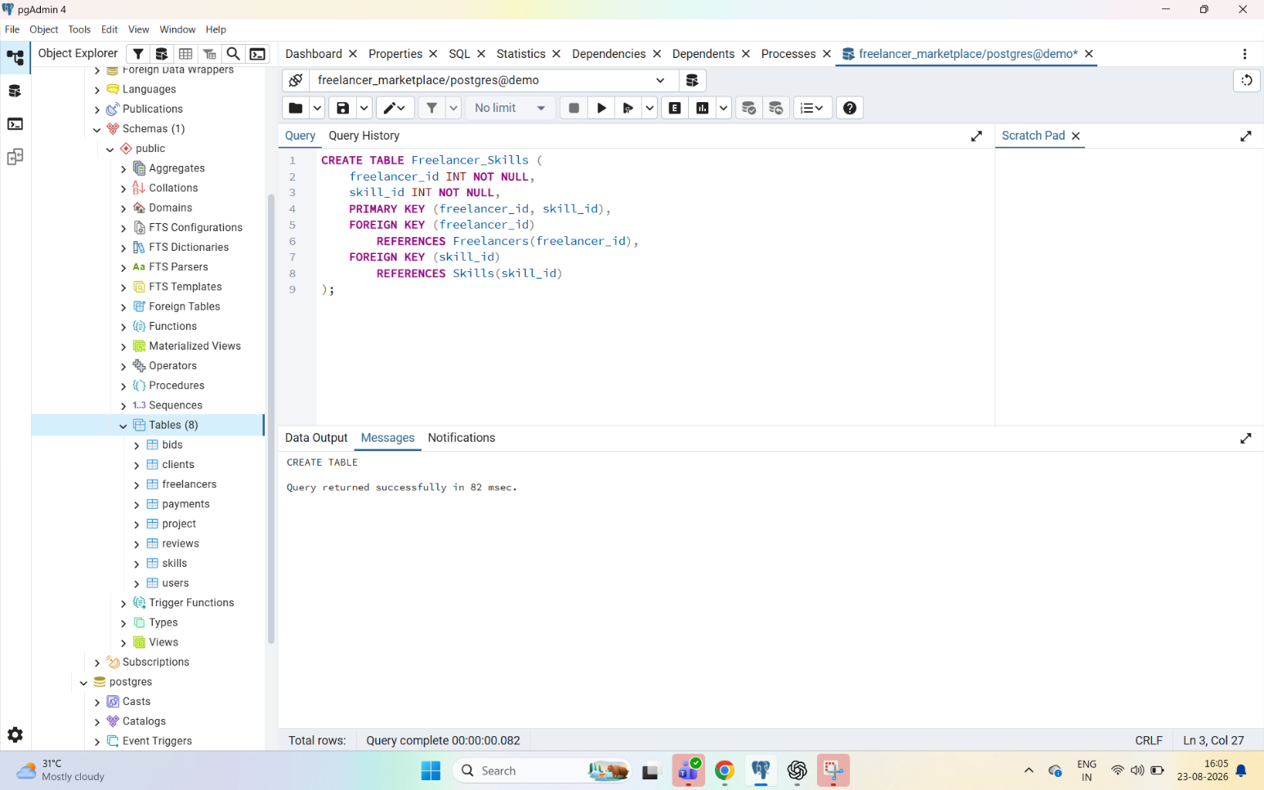
Figure 4.8: Creating the Freelancer_Skills relationship table
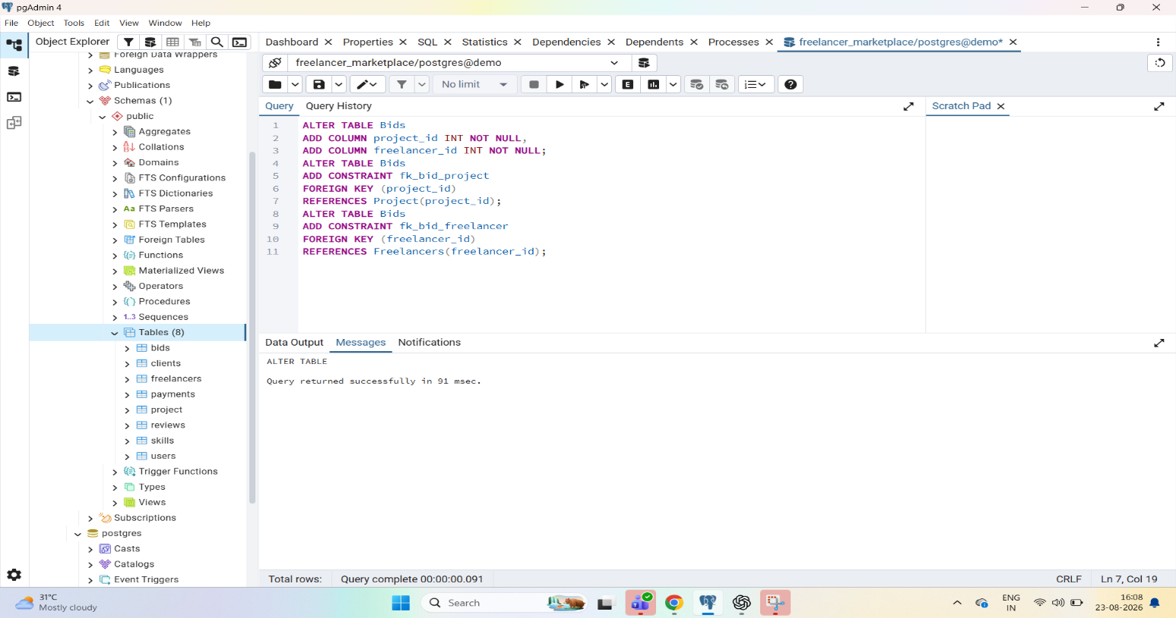
Figure 4.9: Adding foreign keys to the Bids table
4.6 Displaying the final list of tables
Step 7 was to display the final list of tables created in the database by querying the information_schema catalogue. The output of this query is presented in Chapter 6 (Figure 6.1).
4.7 Integrity constraints applied
Table 4.1 summarises the integrity constraints that were applied in the statements shown above.
Table 4.1: Integrity constraints applied to the tables
Entity | Role | Specific attributes
FREELANCER | Supertype | freelancer_id (PK), name, email, contact_no, hourly_rate, location, skills_summary (multivalued), total_experience_years (derived)
INDIVIDUAL FREELANCER | Subtype | individual_id, pan_no (Permanent Account Number, used for taxation and identity verification)
COMPANY FREELANCER | Subtype | company_id, company_name, registration_no (government registration number), website

Chapter 5: Code Snippets (SQL DDL)
This chapter presents the SQL statements that were executed in the pgAdmin 4 Query Tool, together with an explanation of how each of them works. The statements are grouped by the type of operation: table creation with constraints, structural modification with ALTER TABLE, relationship tables and foreign keys, and verification.
Example 01: Creating the Users table
CREATE TABLE Users (
user_id SERIAL PRIMARY KEY,
name VARCHAR(100) NOT NULL,
email VARCHAR(150) UNIQUE NOT NULL,
phone VARCHAR(15),
user_type VARCHAR(20) NOT NULL
CHECK (user_type IN ('Client', 'Freelancer'))
);
This statement creates the users table. The SERIAL data type generates an auto-incrementing integer, and together with PRIMARY KEY it gives every user a unique identifier without manual entry. NOT NULL on name and user_type makes them mandatory. UNIQUE NOT NULL on email guarantees that every user has an e-mail address and that no two users share one. The optional phone column has no constraint, so it may be left empty. The CHECK constraint on user_type permits only the values Client and Freelancer, so any other value is rejected by the database.
Example 02: Creating the Projects table
CREATE TABLE Projects (
project_id SERIAL PRIMARY KEY,
title VARCHAR(200) NOT NULL,
description TEXT,
budget DECIMAL(10,2) NOT NULL CHECK (budget > 0),
status VARCHAR(20) DEFAULT 'Open'
CHECK (status IN ('Open', 'In Progress', 'Completed', 'Cancelled')),
start_date DATE,
deadline DATE
);
This statement creates the table that stores the projects posted by clients. The budget is stored as DECIMAL(10,2), a fixed-point number suited to money values, and the CHECK (budget > 0) condition prevents zero or negative budgets. The status column combines two constraints: DEFAULT 'Open' assigns the value Open to a newly posted project when no status is supplied, and CHECK restricts the status to the four permitted values. The description is stored as TEXT because it can be long, and the dates use the DATE type.
Example 03: Renaming a table
ALTER TABLE projects
RENAME TO project;
The ALTER TABLE ... RENAME TO command changes the name of the table from projects to project. Only the name changes; the columns, constraints and any stored data remain exactly as they were.
Example 04: Adding a column
ALTER TABLE project
ADD COLUMN remarks VARCHAR(255);
The ADD COLUMN clause extends the existing project table with a new column named remarks, which can hold up to 255 characters. Because no constraint is specified, the column accepts null values, so existing rows are not affected.
Example 05: Dropping a column
ALTER TABLE project
DROP COLUMN remarks;
The DROP COLUMN clause removes the remarks column, together with any data stored in it, from the project table. This restores the table to its earlier structure and demonstrates that the schema can be changed after creation without recreating the table.
Example 06: Creating a relationship (junction) table
CREATE TABLE Freelancer_Skills (
freelancer_id INT NOT NULL,
skill_id INT NOT NULL,
PRIMARY KEY (freelancer_id, skill_id),
FOREIGN KEY (freelancer_id)
REFERENCES Freelancers(freelancer_id),
FOREIGN KEY (skill_id)
REFERENCES Skills(skill_id)
);
This table implements the many-to-many relationship “Freelancer has Skill”. Each row links one freelancer to one skill. The composite primary key (freelancer_id, skill_id) ensures that the same skill cannot be recorded twice for the same freelancer, while the two FOREIGN KEY constraints ensure that only existing freelancers and existing skills can be linked, which maintains referential integrity.
Example 07: Adding foreign keys to the Bids table
ALTER TABLE Bids
ADD COLUMN project_id INT NOT NULL,
ADD COLUMN freelancer_id INT NOT NULL;
ALTER TABLE Bids
ADD CONSTRAINT fk_bid_project
FOREIGN KEY (project_id)
REFERENCES Project(project_id);
ALTER TABLE Bids
ADD CONSTRAINT fk_bid_freelancer
FOREIGN KEY (freelancer_id)
REFERENCES Freelancers(freelancer_id);
These statements connect each bid to the project it is for and to the freelancer who placed it. The first ALTER TABLE adds the two mandatory columns project_id and freelancer_id. The next two add named FOREIGN KEY constraints: fk_bid_project references the primary key of the project table (which was renamed in Example 03), and fk_bid_freelancer references the primary key of the freelancers table. Naming the constraints makes them easy to identify and to drop or modify later. Together they implement the one-to-many relationships “Project receives Bid” and “Freelancer places Bid” of the ER model.
Example 08: Displaying the list of tables
SELECT table_name
FROM information_schema.tables
WHERE table_schema = 'public'
AND table_type = 'BASE TABLE'
ORDER BY table_name;
This query reads the information_schema catalogue, which PostgreSQL maintains automatically, and lists the names of all ordinary tables in the public schema in alphabetical order. It provides a check on the whole implementation by showing exactly which tables exist in the database.

Chapter 6: Results
6.1 Design results
The conceptual design stage produced two diagrams. The ER diagram (Figure 3.1) contains eight entities (Client, Project, Bid, Freelancer, Contract, Payment, Review and Skill) connected by seven relationships: five one-to-many, one one-to-one and one many-to-many. The EER diagram (Figure 3.2) retains all of these and adds the ISA specialization of Freelancer into Individual Freelancer and Company Freelancer, giving eight relationships in total. Derived attributes (such as age, days_remaining, duration_days, net_amount and rating_stars) and multivalued attributes (such as attachments, skills_summary, invoice_numbers, images and aliases) are clearly marked in both diagrams.
6.2 Execution results
Each of the statements documented in this report was executed in pgAdmin 4. Table 6.1 lists the operations and their outcomes as reported in the Messages tab.
Table 6.1: Outcome of the operations executed
Table | Constraint | Column(s) and purpose
users | PRIMARY KEY | user_id (SERIAL) uniquely identifies each user.
users | NOT NULL | name and user_type must always have a value.
users | UNIQUE, NOT NULL | email must be present and cannot repeat.
users | CHECK | user_type must be either Client or Freelancer.
projects / project | PRIMARY KEY | project_id (SERIAL) uniquely identifies each project.
projects / project | NOT NULL | title and budget must always have a value.
projects / project | CHECK | budget must be greater than 0; status must be Open, In Progress, Completed or Cancelled.
projects / project | DEFAULT | status is set to Open when no value is given.
freelancer_skills | PRIMARY KEY (composite) | (freelancer_id, skill_id) — a freelancer cannot be linked to the same skill twice.
freelancer_skills | FOREIGN KEY | freelancer_id references freelancers; skill_id references skills.
bids | NOT NULL | project_id and freelancer_id must always have a value.
bids | FOREIGN KEY | fk_bid_project references project(project_id); fk_bid_freelancer references freelancers(freelancer_id).

6.3 Final list of tables
Running the query of Example 08 returned nine rows, confirming that the database contains the tables shown in Figure 6.1.
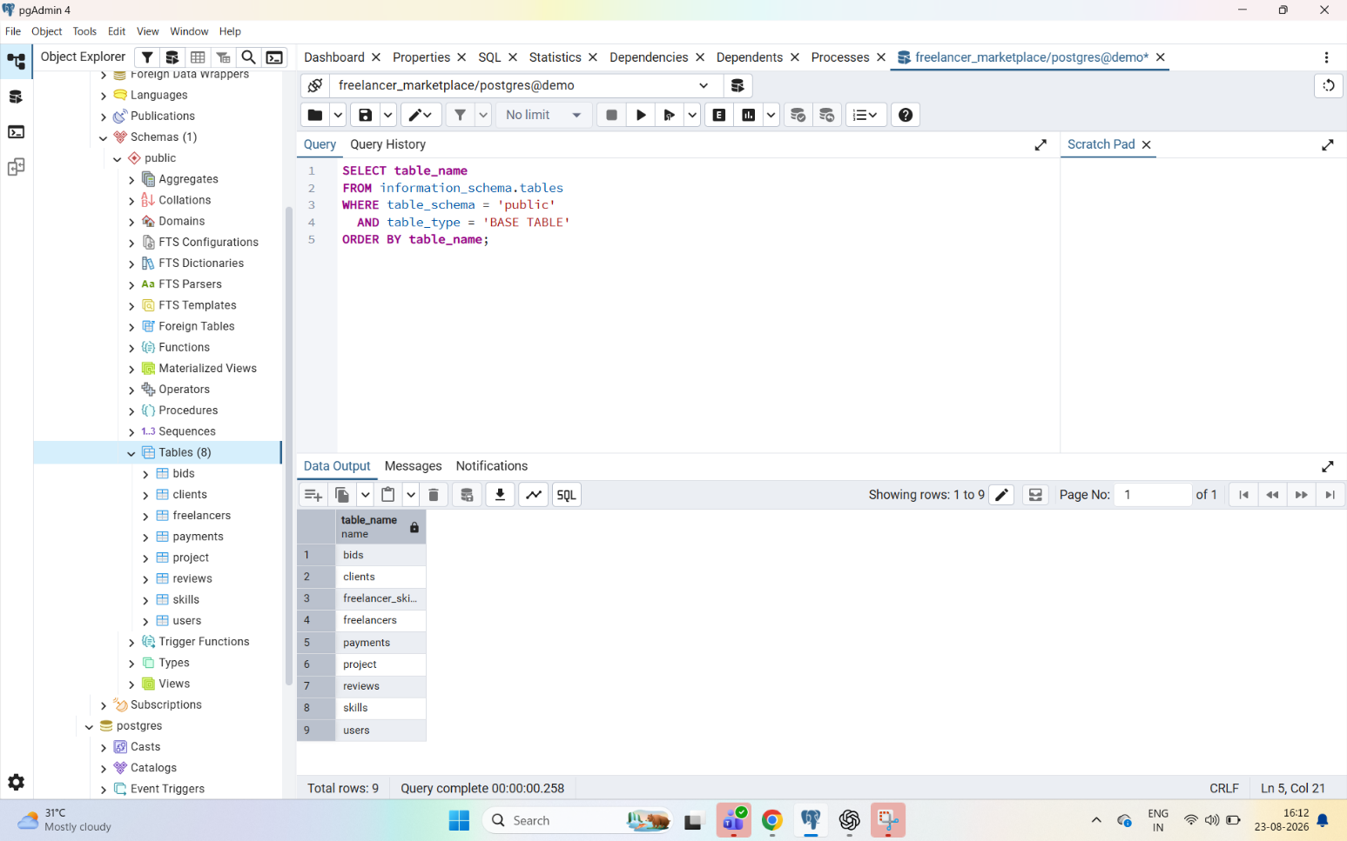
Figure 6.1: Final list of tables in the freelancer_marketplace database
Table 6.2: Tables in the freelancer_marketplace database
Operation | Command reported | Result | Time (ms)
Create users table | CREATE TABLE | Successful | 415
Create projects table | CREATE TABLE | Successful | 92
Rename projects to project | ALTER TABLE | Successful | 94
Add remarks column | ALTER TABLE | Successful | 92
Drop remarks column | ALTER TABLE | Successful | 99
Create freelancer_skills table | CREATE TABLE | Successful | 82
Add foreign keys to bids | ALTER TABLE | Successful | 91
USE freelancer_marketplace; | — | Syntax error (SQLSTATE 42601): not supported by PostgreSQL | —

The results show that the design was successfully converted into a working relational structure: constraints reject invalid values (for example an unknown user_type, or a budget that is not positive), foreign keys link the related tables, and the DDL commands allowed the structure to be modified after creation.
6.4 Execution of code
6.5 Final output
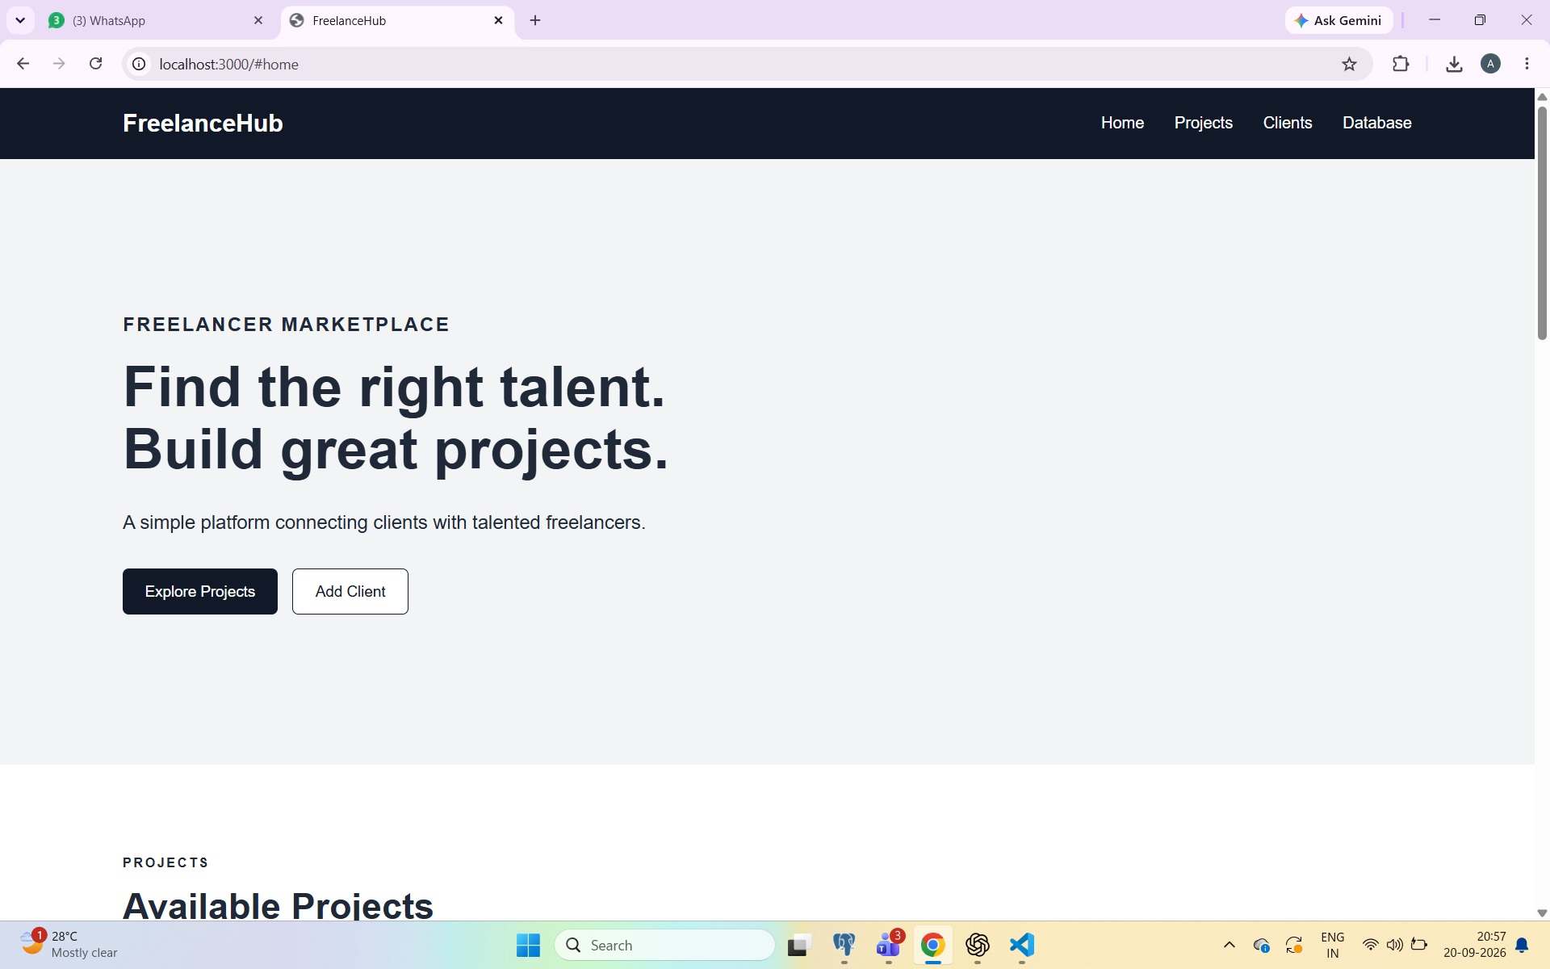

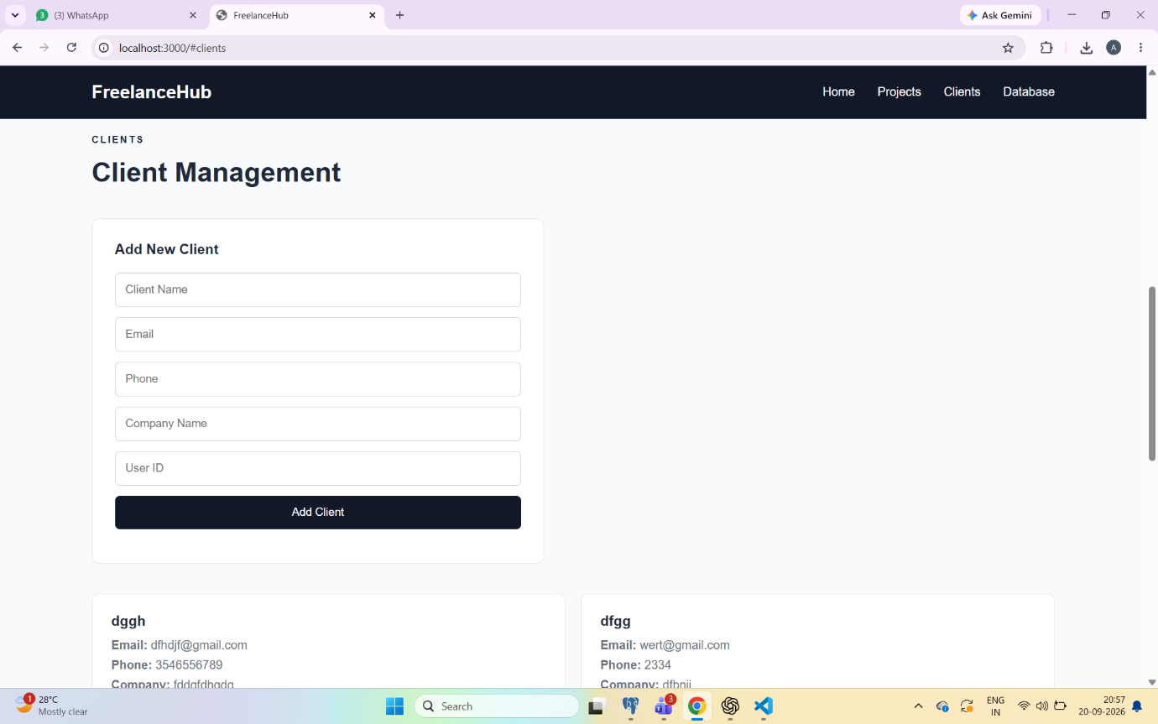

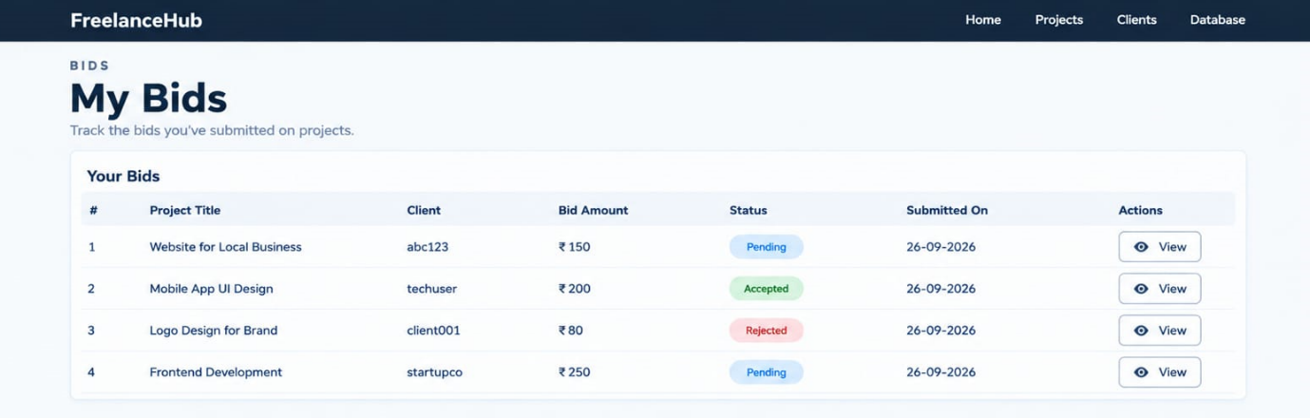

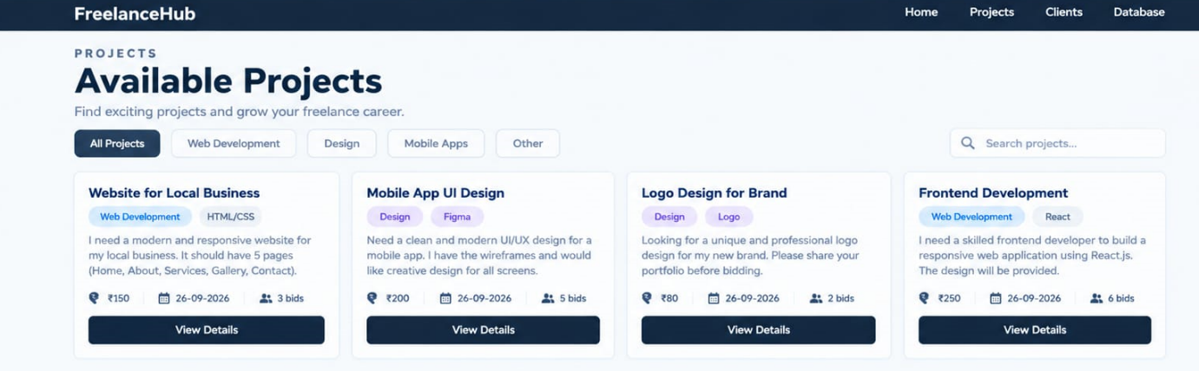
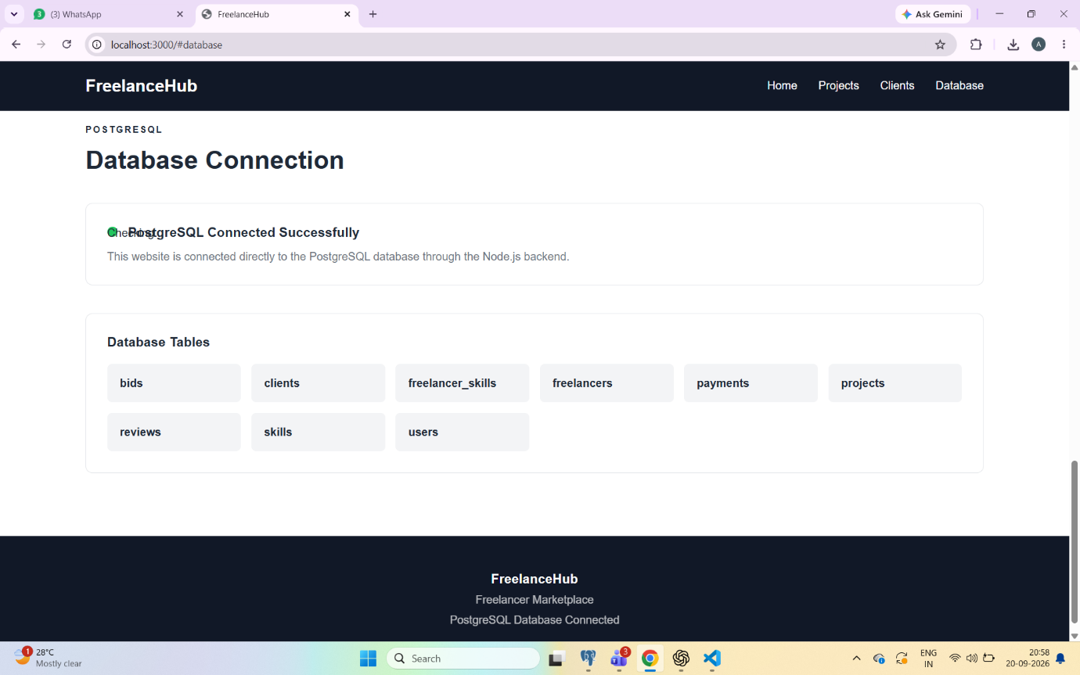

Chapter 7: Conclusion
The Freelancer Marketplace database was successfully designed and implemented, from the conceptual model to a working PostgreSQL database. The ER model captured the eight entities, their attributes and the seven relationships that describe how clients, projects, bids, freelancers, contracts, payments, reviews and skills are connected. The EER model extended this design with ISA specialization, separating Individual Freelancers (identified by PAN) from Company Freelancers (identified by registration number), which represents real-world scenarios more accurately and reduces redundancy.
In the implementation, DDL commands were used to create the tables and to modify their structure through rename, add column and drop column operations, while primary keys, foreign keys, NOT NULL, UNIQUE, CHECK and DEFAULT constraints kept the data accurate and consistent. A junction table resolved the many-to-many relationship between freelancers and skills, and foreign keys connected bids to projects and freelancers. The list of tables displayed at the end verified that the database had been built as intended. During the work it was also learnt that PostgreSQL does not support the USE statement, and that the working database is selected through the connection instead.
The current implementation concentrates on the database structure and has some limitations. The tables created so far do not yet include a contract table or the Individual and Company Freelancer subtype tables from the EER model, the derived and multivalued attributes have not yet been given a physical form (for example through generated columns or separate tables), and no data has been inserted or queried. These points suggest natural future enhancements: completing the schema for contracts and the freelancer subtypes, adding sample data and DML/SELECT queries, adding indexes, views and triggers, and finally connecting the database to a web or mobile application for the Freelancer Marketplace.

